


(TOTAL HEALTHCARE SOLUTIONS PROVIDER)

P. O. Box GP 2821 |  | Email: beautifulcreationsgh@yahoo.com
Accra - Ghana |  | bcclgh@gmail.com
Tel: (233) 0302 667171, Hotline: 0243111199 |  | Website: www.bcmedicals.com
Your Ref: | Our Ref: | Date: {{dateDay}}^{{{daySuffix}}} {{dateMonth}}, {{dateYear}}

PROFORMA INVOICE
PROFORMA NO. | {{sqNumber}}
CONSIGNEE NAME | {{hospitalName}}
CONSIGNEE ADDRESS | {{hospitalAddress}}

NO | ITEM DESCRIPTION | QUANTITY | UNIT PRICE  GHS | TOTAL COST  GHS
{{#lineItems}}{{nums}} | {{description}} | {{qty}} | {{unitPrice}} | {{totalPrice}}{{/lineItems}}
TOTAL AMOUNT |  |  |  | {{grandTotal}}

AMOUNT IN WORDS: {{grandTotalWords}}.

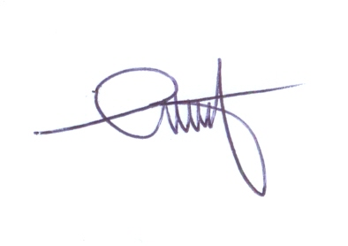

.………………………
S. D. ANSONG
CEO

